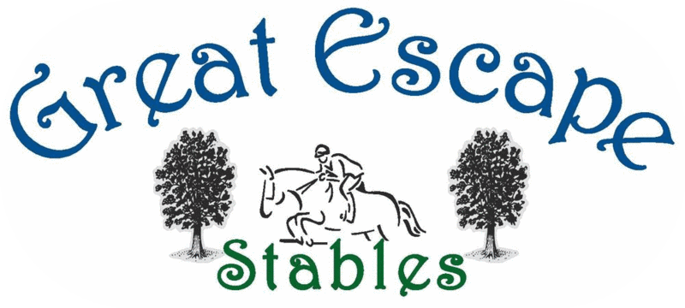

~Horse Options for GES Riders~
Level B+ & above:
Full leasers & boarders must have their own saddle, bridle, girth, saddle pads, sheets, blankets, cooler, halter & lead. All items are outlined in your lease/board paperwork.

Hunter/Jumper Half Lease – up to 3 rides per week (1 must be a lesson) - $750/month
Includes Rides plus basic vet/farrier care.
Extras: Chiropractic as needed usually every 2 to 3 months ($100), Yearly coggins in Jan. ($75)
H/J half leases are intended to get riders started with some jumping and showing once a rider reaches Level C/Jump 1 they will need to consider an out of barn lease or purchase options from below to continue their progress.

Recreational Half Lease – up to 2 rides per week (1 must be a lesson) - $500/month
Includes Rides plus basic vet/farrier care.
Extras: Chiropractic as needed usually every 2 to 3 months ($100).
$150/weekend to horse show plus coggins ($75)
Recreations half leases are intended to get riders started with basic skills and do not jump or show. Once a rider reaches Level C/1, they will need to consider an out of barn lease or purchase options from below to increase their ride time.

Full Lease of a horse at GES – up to 5 rides per week (1 must be a lesson) - $975/month
Extras: Vet, farrier & bi-monthly chiropractic.

Half-Lease on a privately owned horse at GES - up to 4 rides per week (1 must be a lesson) - $850/month
Extras: 50% Vet, farrier & bi-monthly chiropractic.

Out of Barn Full Care Lease – up to 5 rides per week (1 must be a lesson) - $975/month
Extras: Vet, farrier & any additional care the horse requires including supplements.
This lease has no up-front lease cost, you care just paying monthly board on the horse for the term of the lease (usually 6 months to 1 year). This option is similar to owning a horse, but you don’t have to purchase the horse as you return the horse at the end of the lease term. Robyn will network to find horses that fits a care lease from local trainers.

Out of Barn Full Lease – up to 6 rides per week (1 must be a lesson) - $975/month
Extras: Vet, farrier & any additional care the horse requires including supplements.
This lease will have an up-front lease cost anywhere from $1000 and up depending on the horses resume and what you would like it to do. This option is similar to owning a horse, but you don’t have to purchase the horse. You are basically paying a fee up front to borrow someone else’s horse. The more experience the horse has the higher the lease fee. Robyn will network to find a horse that is available for a full ease from local trainers.

Boarding – up to 6 rides per week (1 must be a lesson) - $975/month
Extras: Vet, farrier & any additional care the horse requires including supplements.
With regular boarding you are purchasing a horse as your own to ride and show without limitations.

